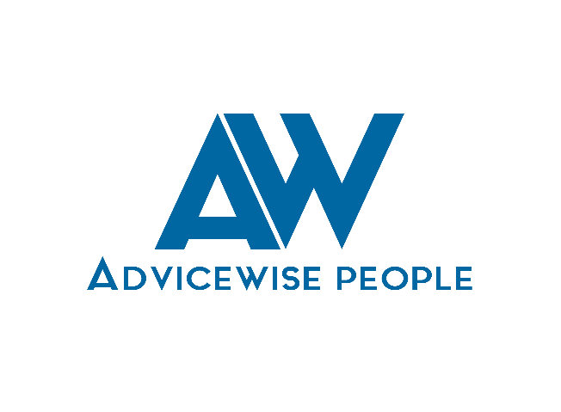
PEOPLE
BUSINESS
EMPLOYMENT LAW

WGANZ COVID-19 BULLETIN 6 April 2020

New information 6 April

Essential Workers COVID-19 Leave Payment Scheme
As mentioned in the last Bulletin, the Government has now announced the details of a new COVID-19 payment will be available to essential businesses for essential workers from Monday 6 April 2020.

The Essential Workers COVID-19 Leave Payment Scheme will support essential workers who have to stay at home to comply with public health guidance, and whose employers are unable to keep paying them.

Work and Income has more information about the scheme, which cannot be used for the same employee at the same time as you are receiving a Wage Subsidy.

The scheme offers the same rates as the Wage Subsidy Scheme of $585.80 per week for full-time workers and $350.00 per week for part-time workers.

Three groups of workers are covered -
- Workers who are self-isolating in accordance with public health guidance because they have contracted the virus or have come into contact with someone who has contracted the virus (or have a dependent they need to care for who is sick or self-isolating)
- Workers deemed at higher risk if they contract COVID-19, in accordance with public health guidance and as such should self-isolate
- Workers who have household members who are deemed at higher risk if they contract COVID-19, in accordance with public health and as such should self-isolate.

Essential employers who can financially support their workers with leave requirements or any special paid leave entitlements – without using the subsidy – should continue to do so.

Employment.govt.nz’s perspective on the scheme is here. It also has useful information on how employee concerns should be raised and considered.

Business Finance Guarantee Scheme
On 1 April the Government also announced a new Business Finance Guarantee scheme, which –
- Allows businesses with annual revenue between $250,000 and $80 million to apply to their banks for loans up to $500,000, for up to three years. The scheme will offer a total of $6.25 billion in loans to New Zealand businesses.
- The Government is guaranteeing 80% of the risk, while the banks are covering the remaining 20%. A normal lending process will be followed by the banks, which will make the lending decisions. Further details can be found on the banks’ websites.

Q&A are available here.

This bulletin is brought to you by the Window and Glass Association’s free employment helpline 0800 692 384. If you have any questions or would like to discuss the bulletin above, please call Philip or Anthony on the helpline.

